daire, logo, yazı tipi, simge, sembol içeren bir resim

Açıklama otomatik olarak oluşturuldu

SWE573

project report

Instructor: Suzan Üsküdarlı

Ayhan Çavdar

2022719039

*Memorycloud*

<https://github.com/ayhncvdr/swe573_cavdar.git>

<http://34.77.211.252:8000/>

**HONOR CODE**

Related to the submission of all the project deliverables for the Swe573 2022 Fall

semester project reported in this report, I Ayhan Çavdar declare that:

- I am a student in the Software Engineering MS program at Bogazici University and

am registered for Swe573 course during the Spring 2023 semester.

- All the material that I am submitting related to my project (including but not limited to the project repository, the final project report, and supplementary documents)

have been exclusively prepared by myself.

- I have prepared this material individually without the assistance of anyone else

with the exception of permitted peer assistance which I have explicitly disclosed in

this report.

Ayhan Çavdar



**Table of Contents**

**1.** **Overview** 3

**2.** **Software Requirements Specification** 4

**3.** **Design (Software & Mockups)** 6

**3.1 Class Diagram** 6

**3.2 Website Mockup** 6

**3.3 Actual Design** 10

**3.4 Software Design** 14

**3.4.1 Backend Design with Django and GeoDjango** 14

**3.4.2 Frontend Design with HTML/CSS/JavaScript** 14

**3.4.3 Database Design with PostGIS** 15

**3.4.4 Dockerization and Deployment on GCP** 15

**4.** **Status of The Project** 15

**5.** **System Manual** 16

**5.1 Installation Steps** 16

**5.2 Troubleshooting** 17

**6.** **User Manual** 17

**6.1 Sign In / Sign Up** 17

**6.2 Home Page** 17

**6.3 Discover Page** 18

**6.4 New Post** 18

**6.5 Profile Section** 18

**6.6 Memory Details** 18

**6.7 Deleting Memories** 18

**6.8 Searching** 18

**7.** **Test Results** 19

**7.1 Unit Tests** 19

**7.2 User Testing** 20

**8.** **Video Link** 21

# **Overview**

Memorycloud is a web-based application that allows users to store, organize, and share their memories. The application's goal is to provide a user-friendly interface and a variety of capabilities to improve the user experience when managing personal memories.

The primary purpose of Memorycloud is to allow users to generate digital representations of their memories, such as photographs, videos, and textual descriptions. It supports social sharing, allowing users to share their memories with friends, family, or the larger community.

The application uses the latest technologies and frameworks to create a smooth and responsive user experience. Its backend is built on the Django framework, which provides sophisticated data management and security capabilities. The front end is developed with HTML, CSS, and JavaScript to provide an easy and aesthetically appealing experience.

Key Features of Memorycloud include:

* User Registration and Authentication: Users may establish accounts and securely authenticate themselves to access their memories.
* Memory Creation and Organization: Users may upload images, videos, write descriptions, and choose places for their experiences to create unique memories.
* Social Sharing: Users may share their memories with the Memorycloud community. This increases user interaction and connection.
* Search and Filtering: Memorycloud has search and filtering capabilities, allowing users to rapidly identify specific memories based on keywords, dates, location, and any other information.
* Like and Comment: Users may like or comment on the memories.
* Following Other Users: Users may follow others and see their memories on the home page.

Memorycloud is being developed iteratively and collaboratively, including feedback from user testing and continual improvement. The project developer adheres to industry best practices to ensure code quality, security, and scalability.

Memorycloud's goal is to give users a centralized and user-friendly platform for saving and sharing their treasured memories, creating personal relationships, and generating a sense of nostalgia and emotional well-being.

# **Software Requirements Specification**

1. The system shall provide a web interface accessible via a web browser. **(completed)**
2. The users should be able to access the website all the time. **(completed)**
3. The users should be able to upload their stories without data loss or corruption. **(completed)**
4. The system shall provide accurate search results based on user queries. **(completed)**
5. The users should be able to search for stories based on location. **(completed)**
6. The users should be able to search for stories based on location radius selection. **(Not completed)**
7. The users should be able to search for stories based on tags. **(completed)**
8. The users should be able to search for stories based on the story's title. **(completed)**
9. The users should be able to comment on other users' stories. **(completed)**
10. The users should be able to delete their memories. **(completed)**
11. The users should be able to like other users' memories. **(completed)**
12. The users should be able to follow other users. **(completed)**
13. The users should be able to add a title to their stories. **(completed)**
14. The users should be able to add a location to their stories. **(completed)**
15. The users should be able to view the story's location in a map view. **(completed)**
16. The users should be able to add tags to their stories. **(completed)**
17. The users should be able to upload files of their stories. **(completed)**
18. The users should be able to add a specific date to their stories. **(completed)**
19. The users should be able to add a specific time to their stories. **(completed)**
20. The users should be able to add a range of dates to their stories. **(completed)**
21. The users should be able to add decade information to their stories. **(completed)**
22. The users should be able to view all the users' stories in a list format. **(completed)**
23. The users should be able to view followed users' stories in a list format. **(completed)**
24. The users should be able to create an account using their personal information. **(completed)**
25. The users should be able to log in to their accounts by entering their usernames and password. **(completed)**
26. The users should be able to upload their pictures to their accounts. **(completed)**
27. The users should be able to view all the comments on a separate page. **(completed)**
28. The users should be able to view all the likes on a separate page. **(completed)**
29. The users should be able to view the number of comments for a story. **(completed)**
30. The users should be able to view the number of likes for an account. **(completed)**
31. The users should be able to view the full story on a separate page. **(completed)**
32. The users should be able to perform search actions on any page. **(completed)**
33. The users should be able to update their account information. **(completed)**
34. The users should be able to log out from their accounts. **(completed)**
35. The system shall provide a simple interface for viewing and uploading their stories. **(completed)**

# **Design (Software & Mockups)**

## **3.1 Class Diagram**

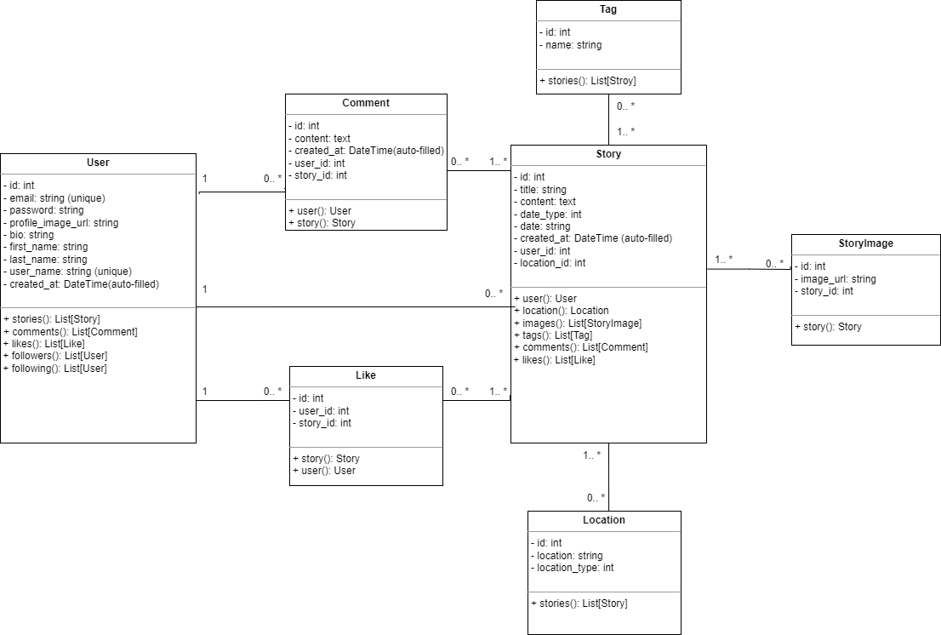

**3.2 Website Mockup**During the initial stages of the project, the below demo designs were created to visualize the overall structure and user interface of the Memorycloud website. These mockups provided a starting point for discussions and served as a reference for the developer. However, as the semester progressed, significant changes and improvements were made to the initial designs based on user feedback and evolving project requirements.metin, ekran görüntüsü, yazılım, web sayfası içeren bir resim

Açıklama otomatik olarak oluşturuldumetin, ekran görüntüsü, yazılım, web sayfası içeren bir resim

Açıklama otomatik olarak oluşturuldu

metin, ekran görüntüsü, yazılım, web sayfası içeren bir resim

Açıklama otomatik olarak oluşturuldumetin, ekran görüntüsü, yazılım, web sayfası içeren bir resim

Açıklama otomatik olarak oluşturuldu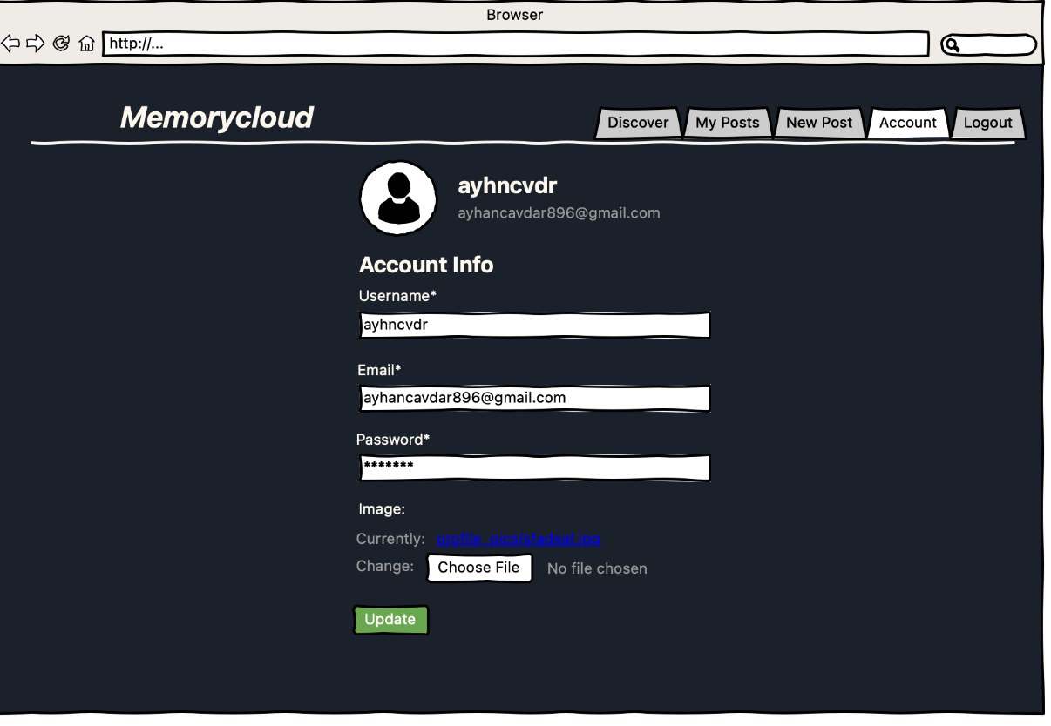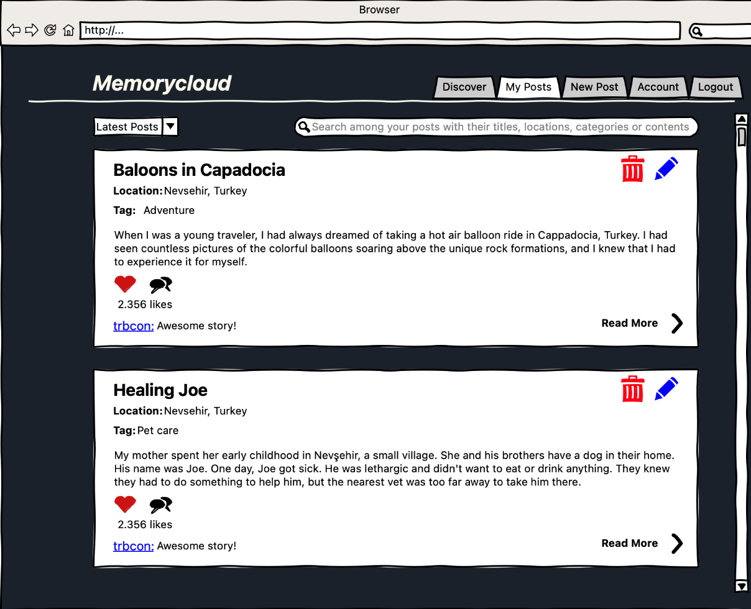

## **3.3 Actual Design**

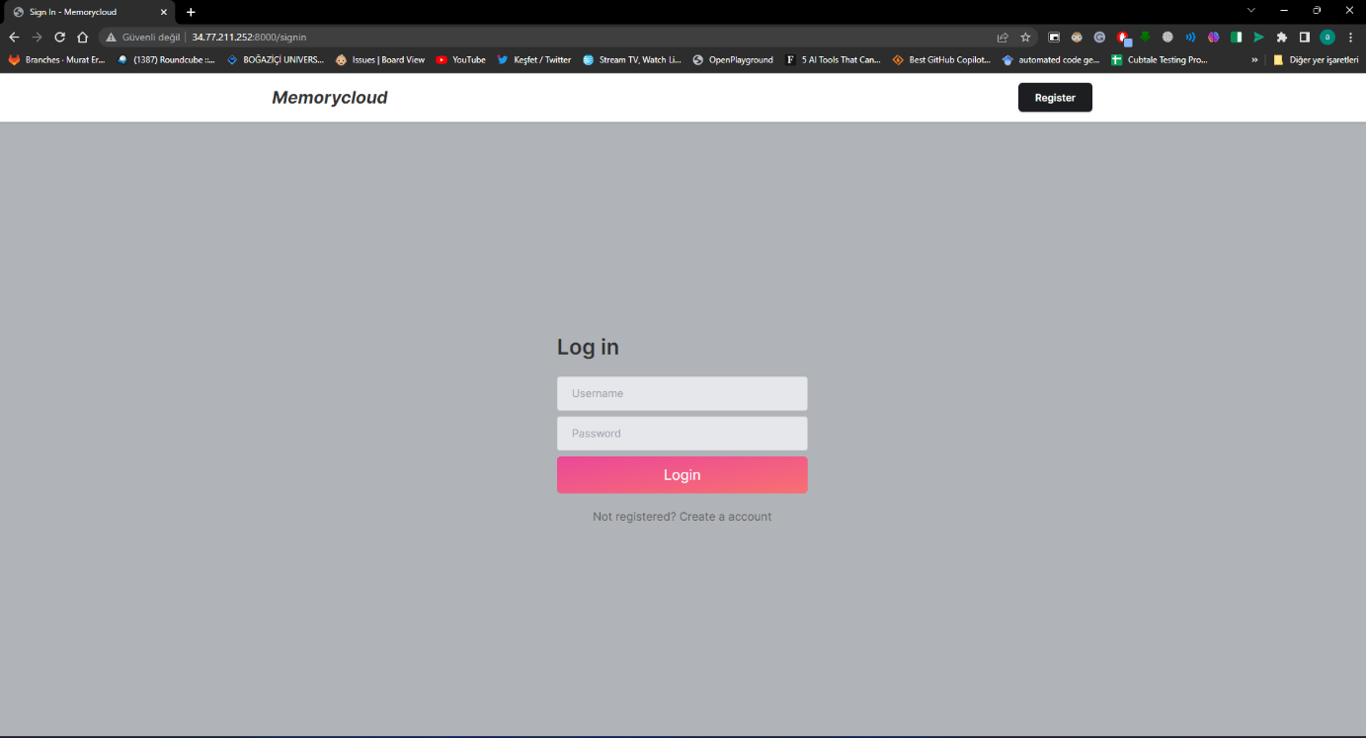

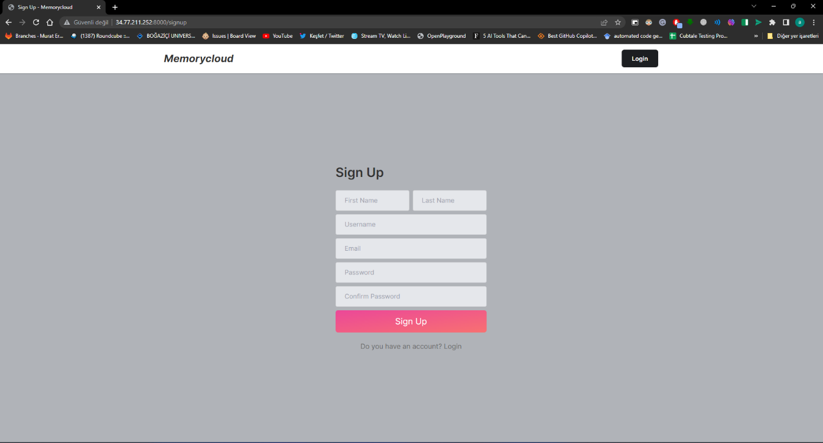

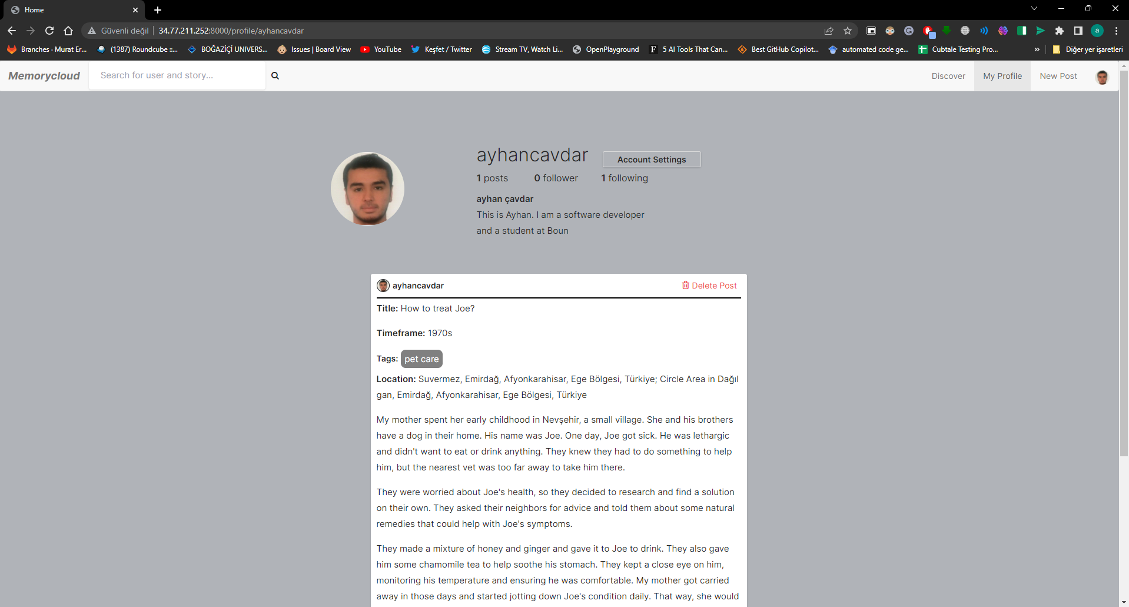

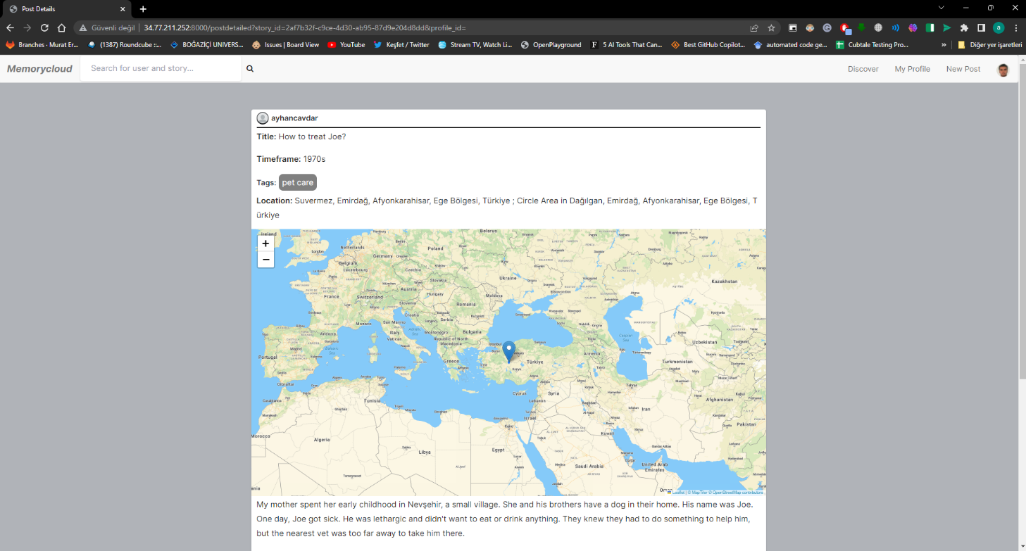

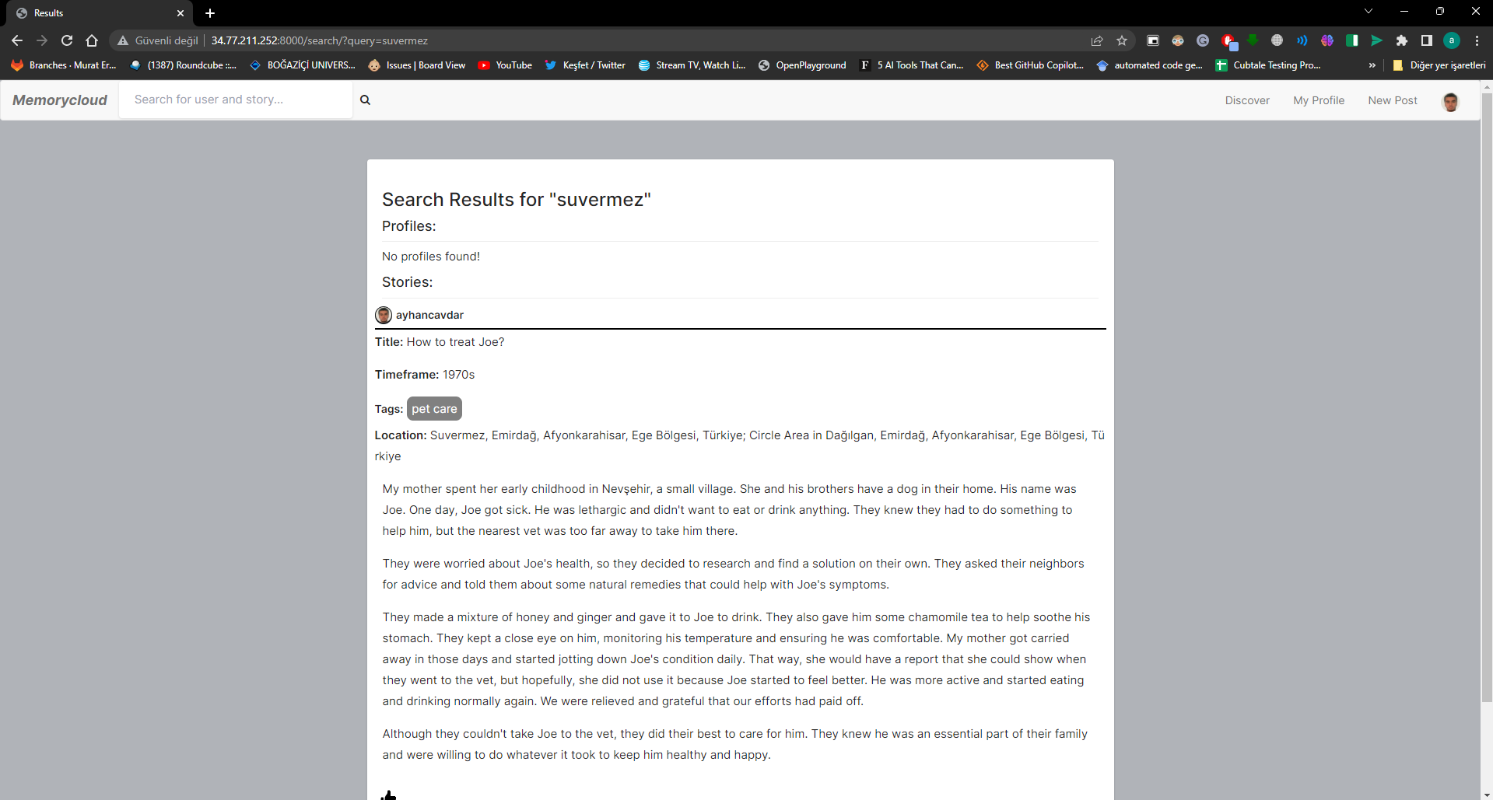

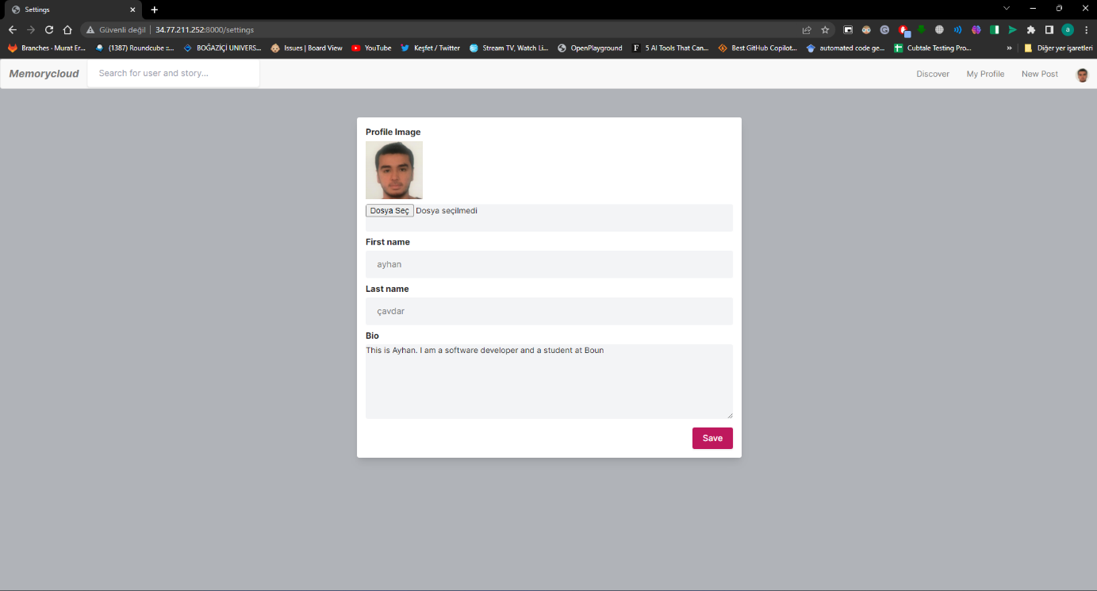

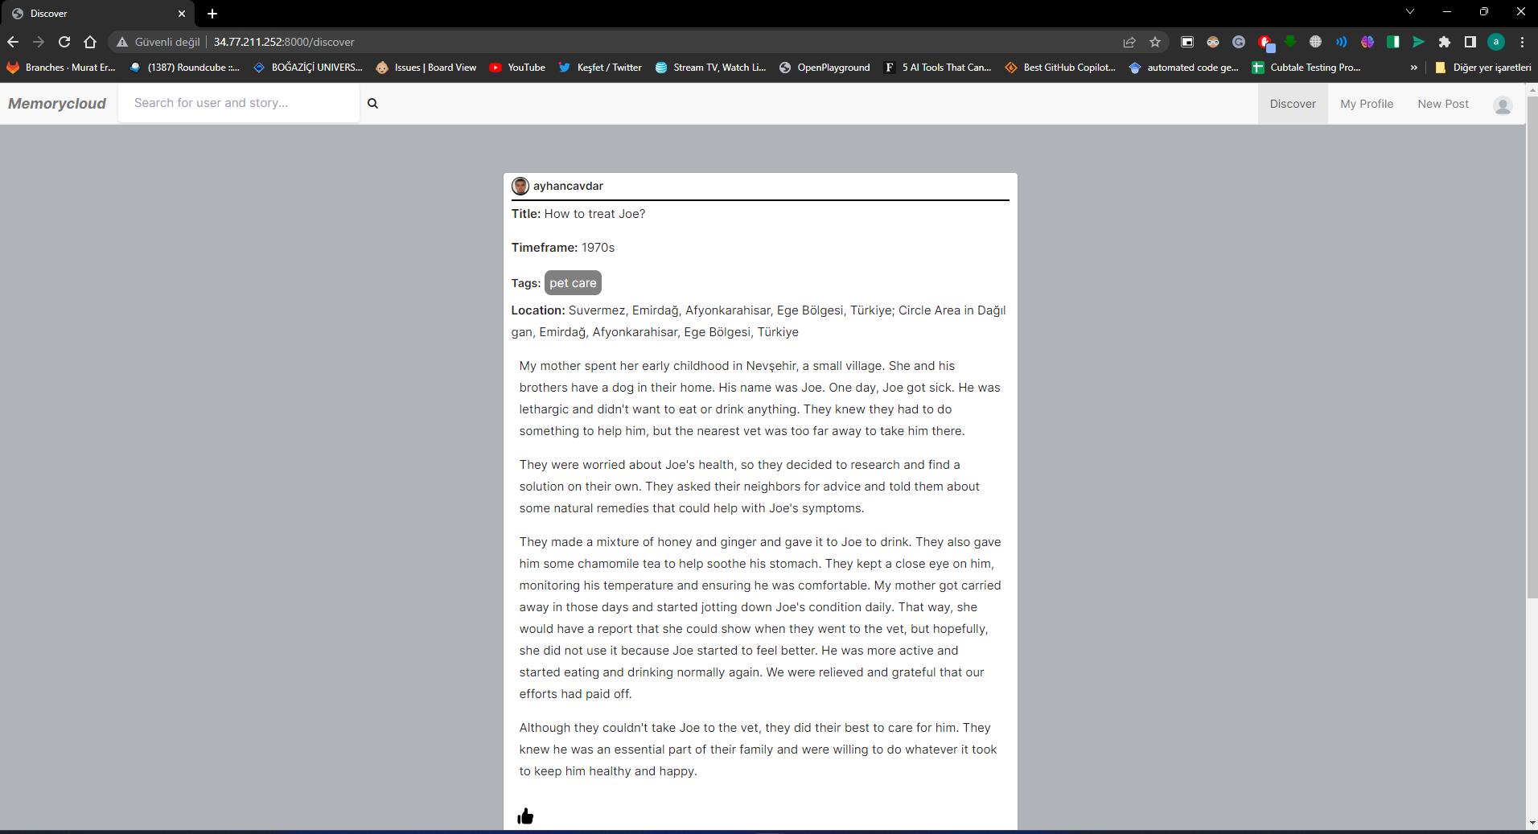

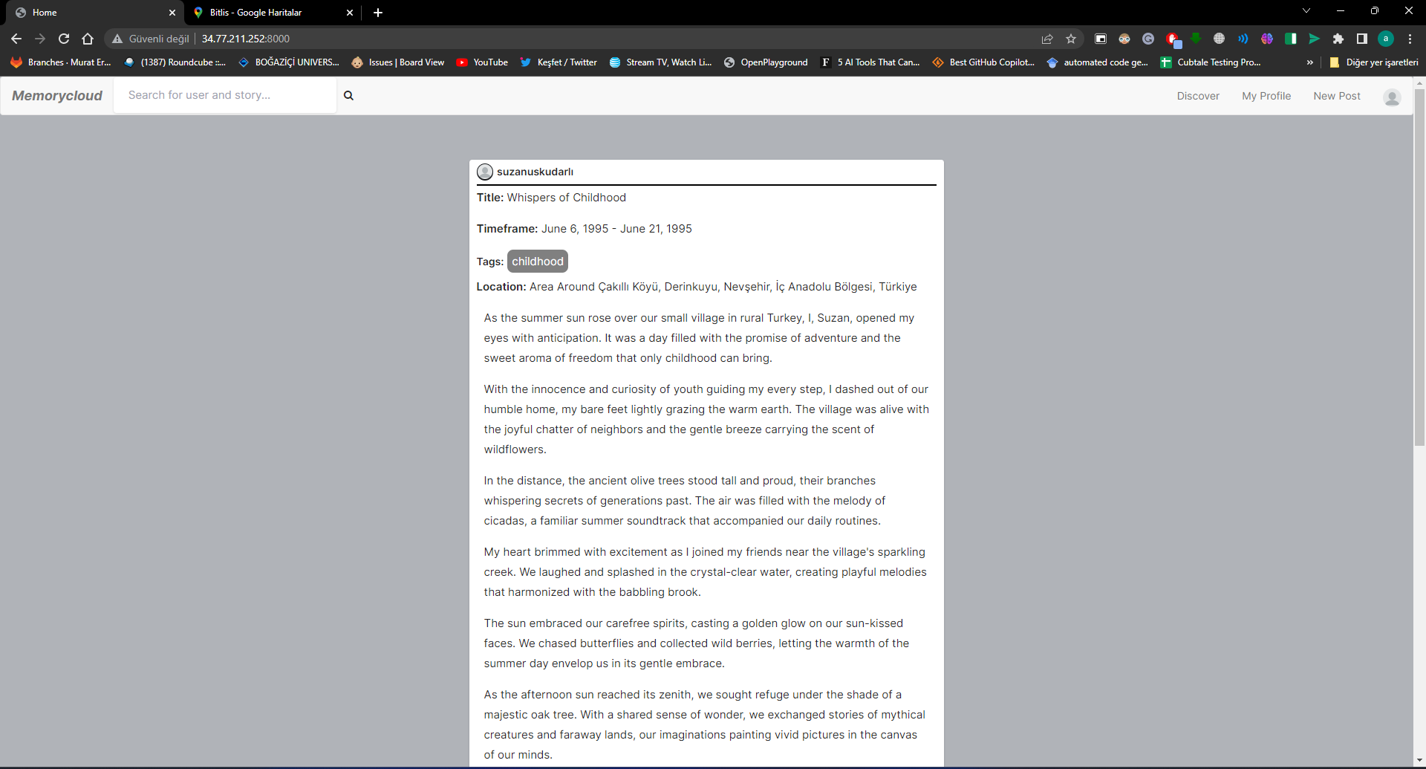

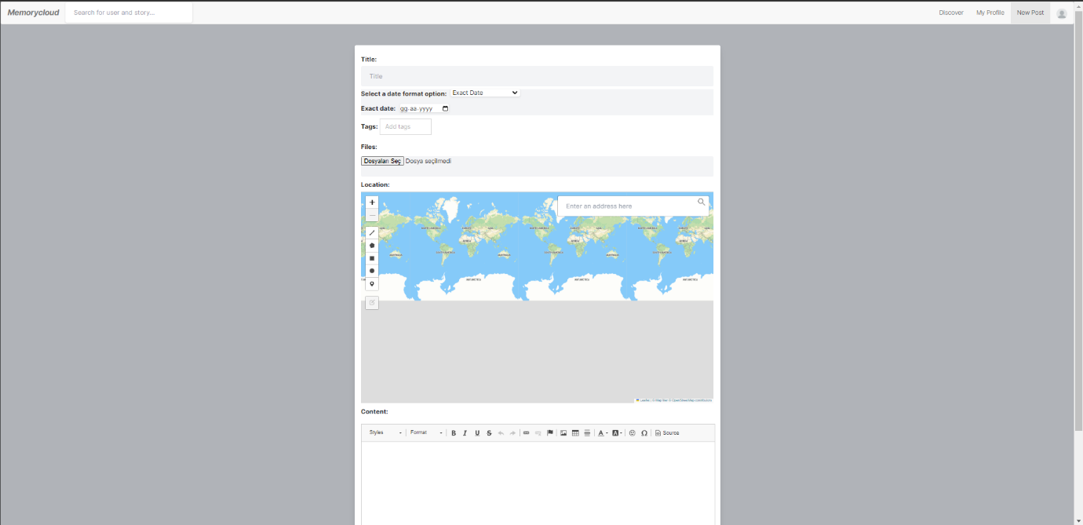

## **3.4 Software Design**

Memorycloud is a project that combines backend and frontend technologies to produce a powerful and user-friendly online application for organizing and sharing memories. Django, GeoDjango, Leaflet, and OpenCage are among the frameworks and components used in the software design.

### **3.4.1 Backend Design with Django and GeoDjango**

The Memorycloud application is built on Django, a robust and extensible web framework. It follows the Model-View-Controller (MVC) architectural model, allowing for quick backend code creation and maintenance. Django is a Python-based high-level framework for constructing online applications that manage responsibilities, including URL routing, request processing, database operations, and user authentication.

GeoDjango, a Django plugin that adds support for geographic fields and spatial operations, is used for geographical data management in the project. GeoDjango uses the PostGIS database's features, allowing for storing, querying, and modifying geographic data. This allows the Memorycloud application to manage location-based features and deliver services like geolocation tagging and searching.

### **3.4.2 Frontend Design with HTML/CSS/JavaScript**

The Memorycloud application's frontend design is based on HTML, CSS, and JavaScript. HTML provides the structural underpinning of webpages, while CSS defines the visual display and layout. JavaScript, a dynamic programming language, is used to improve interaction and provide client-side functionality.

The front-end design utilizes contemporary web development standards to build a visually beautiful and intuitive user experience. It guarantees responsive design, allowing the Memorycloud application to quickly adapt to multiple devices and screen sizes. The front end also connects with several tools and frameworks, like Leaflet and OpenCage, to improve the user experience and give mapping and geocoding capabilities.

### **3.4.3 Database Design with PostGIS**

The Memorycloud application's database is built on PostGIS, an extension of the PostgreSQL relational database system. PostGIS extends spatial database functionality, allowing storing, querying, and modifying geographic data. Spatial indexing, complex spatial operations, and interaction with other geospatial tools are all supported.

The database structure is intended to store and retrieve memory-related information as efficiently as possible, including user data, memories, albums, and associated geographical features. PostGIS spatial data enables robust geospatial queries and operations, allowing for location-based searching, mapping, and visualization.

### **3.4.4 Dockerization and Deployment on GCP**

The Memorycloud application is containerized using Docker to provide easy deployment and scalability. Docker allows the program and its dependencies to be encapsulated into portable, isolated containers. This method assures consistent distribution across several settings while simplifying the setup procedure.

The Memorycloud application uses its architecture and capabilities to run on the Google Cloud Platform (GCP). GCP offers scalable and dependable hosting, allowing the application to meet a rising user base and data storage requirements. Configuring the necessary resources, including virtual machines, networking, storage, and load balancers, to guarantee maximum performance and availability is part of the GCP deployment.

# **Status of The Project**

With the ideal deployment and accomplishment of all defined objectives, the Memorycloud project has reached a key milestone. The developer has thoroughly tested the program and a select set of users to ensure its functioning and usefulness.

The Memorycloud project is currently stable and functioning. The developer and users both successfully tested and verified all requirements. The application has been dockerized and deployed on GCP, enabling users to access and use its features reliably and safely.

As the project progresses, the emphasis will change to collecting user input, fixing any identified issues or additions, and constantly developing the application based on user feedback. Regular maintenance, monitoring, and upgrades will be performed to maintain the Memorycloud application's smooth operation and long-term success.

# **System Manual**

This section provides instructions on how to set up and run the Memorycloud project on your local machine using Docker and Linux containers. Before proceeding with the installation and setup, please ensure that you have downloaded and installed Docker from the official website (<https://www.docker.com>). Also, you need to install git.

## **5.1 Installation Steps**

Follow the steps below to install and run the Memorycloud project:

1. Clone the Repository: Download the source code from the Memorycloud project repository on GitHub using the following command:  
   **git clone** [**https://github.com/ayhncvdr/swe573_cavdar.git**](https://github.com/ayhncvdr/swe573_cavdar.git)
2. Set Environment Variables: In the project root directory, locate the .env file. Open it in a text editor and set the necessary environment variables. Ensure that the variables ‘DB_NAME’, ‘DB_USER’, ‘DB_PASSWORD’, ‘DB_HOST’, and ‘DB_PORT’ are configured correctly for your database setup. Here is the .env file I am using:

POSTGRES_USER=***

POSTGRES_PASS=***

POSTGRES_DBNAME=***

DATABASE=***

PG_HOST=***

PG_PORT=***

SECRET_KEY= ***

DEBUG=***

ALLOWED_HOSTS=localhost 127.0.0.1 [::1] 34.77.211.252

GEOAPIFY_KEY=***

(Geoapify key is for searching locations in the map. If you don’t have it, it does not break the app, but that functionality won’t work. So, you can get a new API key from this page: <https://www.geoapify.com/get-started-with-maps-api>)

1. Build and Run Containers: Open a terminal or command prompt and navigate to the project root directory. Run the following command to build and run the containers:

**docker-compose up –build**

Docker will automatically download the required container images and build the application container using the specifications from the Dockerfile. It will also install the necessary packages listed in the requirements.txt file inside the container.

1. Access the Application: Once the dockerization process is complete, you can access the Memorycloud application in your web browser at **localhost:8000**. The application should be up and running, allowing you to register, log in, create memories, and perform various other actions as specified in the project's functionality.

## **5.2 Troubleshooting**

* If you encounter any issues during the installation or setup process, please refer to the project's documentation or reach out to the project development team for assistance.
* Ensure that you have a stable internet connection during the Docker image download and container build process.
* Double-check the configuration of the environment variables in the **.env** file to ensure they match your database setup correctly.

# **User Manual**

This section provides a comprehensive guide on how to use the Memorycloud application. It covers various features and functionalities available to the users.

## **6.1 Sign In / Sign Up**

1. Open the Memorycloud application in your web browser.
2. On the Sign In page, enter your credentials if you already have an account. Otherwise, click on the Sign-Up link to create a new account.
3. If signing up, provide the required information and follow the instructions to complete the registration process.
4. After successful sign in or sign up, you will be redirected to the home page.

## **6.2 Home Page**

1. The Home page displays memories from users you are following.
2. Scroll through the memories to view their details, including the user who posted the memory, the number of likes, comments, and a comment section.
3. Interact with memories by liking, commenting, or clicking on the user's profile to visit their profile page.
4. To create a new memory, click on the "New Post" button.

## **6.3 Discover Page**

1. The Discover page allows you to explore memories from other users.
2. Scroll through the memories to view their details, like the home page.
3. Interact with memories as described in the home page section.

## **6.4 New Post**

1. Click on the "New Post" button to create a new memory.
2. Fill in the required information, including the memory details and optional tags.
3. Optionally, specify the location of the memory using the integrated map.
4. Click on the "Post" button to publish your memory.

## **6.5 Profile Section**

1. Access your own profile by clicking on your username or profile picture.
2. On the Profile page, you can view your own profile information, including your username, bio, and profile picture.
3. Scroll through your own memories to view their details and interact with them.

## **6.6 Memory Details**

1. When viewing a memory's details, you can see the user who posted the memory, the number of likes, comments, location in the map and a comment section.
2. Like the memory by clicking on the "Like" button.
3. Add a comment by typing in the comment box and clicking on the "Comment" button.
4. Click on the user's profile picture or username to visit their profile page.

## **6.7 Deleting Memories**

1. To delete one of your own memories, access the memory details page.
2. Click on the "Delete" button to remove the memory from your profile.

## **6.8 Searching**

1. Use the search bar, usually located at the top of the application, to search for memories and profiles based on user queries.
2. Enter keywords, such as date, location, tags, or comments, to filter the search results.
3. The search results will be displayed on a separate page.

# **Test Results**

The Memorycloud application underwent thorough testing to ensure its functionality and reliability. The following tests were performed:

## **7.1 Unit Tests**

A total of 20 unit tests were implemented in the tests.py file to assess different components and functionalities of the application. These tests cover critical areas and ensure that the code functions as intended. All unit tests were executed, and the results are as follows:

metin, ekran görüntüsü içeren bir resim

Açıklama otomatik olarak oluşturuldu

## **7.2 User Testing**

User testing was conducted to evaluate the application from the perspective of end users. The objective was to identify usability issues, functional bugs, or user experience concerns. The testing process involved a group of users interacting with the application and providing feedback. During the user testing phase, the following observations were made:

* No errors or critical issues were encountered during the testing process.
* The application performed well and responded promptly to user actions.
* Users could successfully navigate through different sections of the application and perform desired tasks.
* The user interface was found to be intuitive and easy to understand.
* All essential features and functionalities were tested and found to be working correctly.

Based on the user testing results, no significant issues or errors were identified. The Memorycloud application demonstrated stability and usability, providing a satisfactory experience to the users.

# **Video Link**

The video is a bit long, but you can watch it in 1.25x 😊

<https://drive.google.com/file/d/1zfczYsxEqzTQKrebrQ28we5XlBgHvtL8/view?usp=sharing>